The first thing to try is to clear the browser cache – this will delete temporary files and forces the web browser to re-download fresh versions of all files for the website.
Be aware this will clear out any other saved passwords you may have so it may be better to just reset your password.
The method to clear the cache will differ depending on the browser you use.
For Chrome see https://support.google.com/accounts/answer/32050?hl=en&co=GENIE.Platform%3DDesktop

If your password still is not accepted after clearing the cache and you are seeing the screen below – click on “sign out”

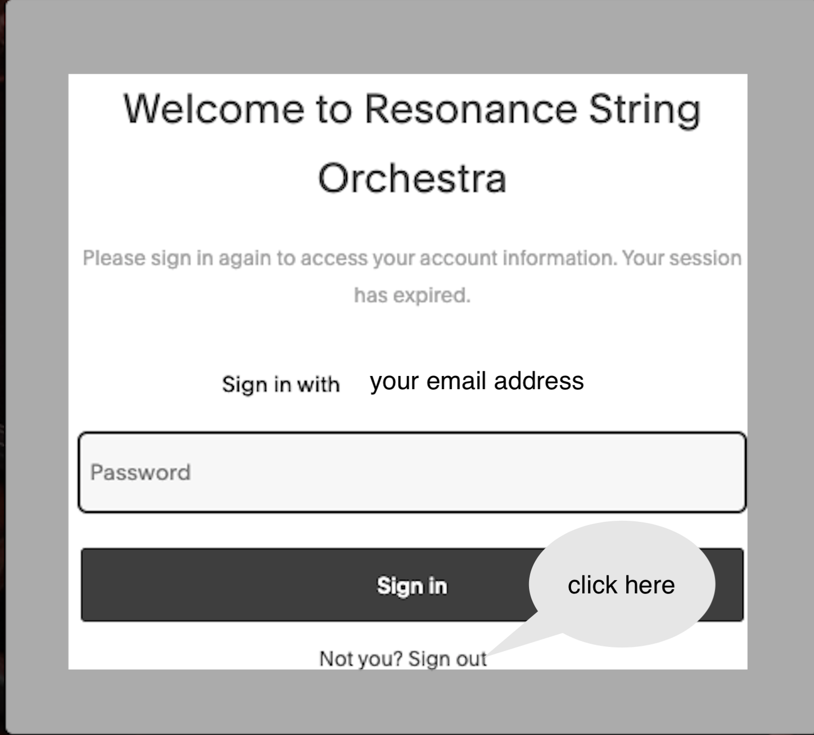

This will take you to the Welcome screen where you can try to enter your password again.
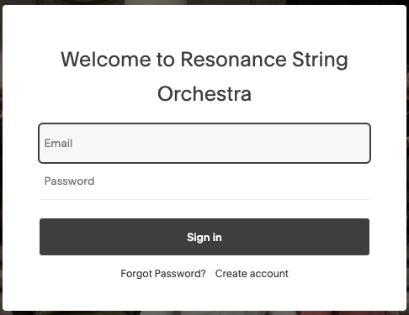

If you still receive an error, click on “Forgot Password”.

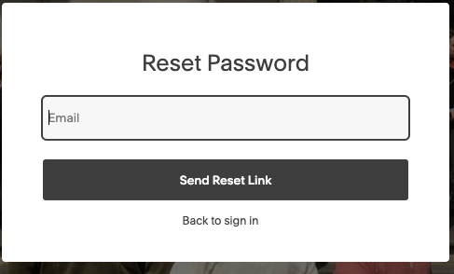

Enter your email address to receive a link to reset your password.

